PD Essentials Meeting
September 12, 2023
MEETING SUMMARY

The September 12, 2023 PD Essentials meeting included 69 early childhood PD providers. There were 111 people registered. Twelve participants were new to PD Essentials. Governance member Cori Hill served as the meeting co-host/producer.

Soft Opener
The soft opener for the virtual meeting was open-ended questions: What is something new that you learned this summer? What made it memorable? This prompt foreshadowed our Tips and Tricks for Trainers focus on making learning memorable. Participants shared a number of new learnings including the future arrival of a new grandchild, that funerals don’t have invitations as weddings do, and “I learned more about CLASS and how to code. I learned best from the practice videos and master coding justifications following scoring.”

PD Essentials Update
State Coordinator Jaye Harvey provided a brief update on PD Essentials with a focus on the changes implemented in 2022-23. With regard to meeting participation:
- Average meeting participation: 66
- Average meeting registration: 113
- Unique participants: 175
- Past participants in VCPD, PDE, or PBC Training: 66%
- Led a breakout room discussion: 26

Jaye shared that our mission and vision remain the same: PD Essentials prepares Virginia’s professional development providers to support those serving all children birth to age five in home, school, and community settings. Our vision is that Virginia’s early childhood professional development providers are well-prepared to support the early childhood workforce.

PD Essentials is funded by the Virginia Department of Education to provide two series of Essentials for Early Childhood Professional Development Providers training annually. In addition,

PD Essentials Meeting Summary Page 2
September 12, 2023

we offer four quarterly meetings, four issues of Pointers for PD Providers, and our website, www.vcpd.net.

Participants in today’s meeting as well as those who participated in one of the 2022-23 meetings were encouraged to respond to a brief survey regarding how we can best meet their needs as a PD provider. The link was shared at the end of the meeting. 2022-23 meeting participants also received a link to the survey via Constant Contact.

Essentials for Early Childhood Professional Development Providers
Registration is open for our fall series of in-person and virtual training. https://web.cvent.com/event/b3da79e0-13ff-4125-9ffa-cc2b3f8e7e44/summary
Jaye reviewed the upcoming opportunities:
Essentials #1: Understanding Adult Learners
Essentials #1 is a two-hour virtual training. In this interactive session, participants explore the key characteristics of adults as learners in order to design and deliver effective and engaging training. Essentials #1 is a prerequisite for Essentials #2, 3a and 3b.
- Tuesday, September 19, 2023, 9:00-11:00 am
- Wednesday, September 20, 2023, 1:00-3:00 pm

Essentials #2: Techniques for Effective and Engaging Early Childhood Training AND
Essentials #3a: Designing Effective and Engaging Early Childhood Training: Part One
Essentials #2 and #3a are in-person trainings offered on the same day. In Essentials #2, participants experience a variety of effective and engaging instructional strategies to replicate in future training that they design. Ideas for openers, closers, memory refreshers, and energy rechargers are shared. In Essentials #3a, participants learn a systematic process for designing training using planning steps, a planning tool, and a template. Strategies to create opportunities for learner participation, reflection, and application are examined. Essentials #1 is a prerequisite.

Essentials #2 and #3a are in-person trainings. Participants attend both sessions on the same day.
- Thursday, October 12, 2023, 9:00 am -3:30 pm, Hampton Inn in Manassas

Essentials #3b: Designing Effective and Engaging Early Childhood Training: Part Two
Essentials #3b is a small-group, virtual session open only to those who have completed Essentials #2 and 3a. Applying the process learned in Essentials #3a, participants will design one portion of a training on a topic of their choice. During the #3b virtual session, they will walk through their training design and receive feedback and coaching from peers and the instructor. Participants in #3a will register for #3b on October 12th, choosing from times on October 20, 23, and 27, 2023.

PD Essentials Meeting Summary Page 3
September 12, 2023

Essentials #4: Delivering Effective and Engaging Early Childhood Training
Essentials #4 is in-person training and addresses instructional delivery techniques. Topics include room arrangement; group size; time allocation; structuring small group activities; PowerPoint, flipcharts, and handouts; and strategies to prevent and respond to challenging participants, technology failure, and other unanticipated training events. Organizational tools including lists for presenter preparation, training materials, and set-up tasks are provided. There are no prerequisites. Registration for Essentials #4 will open on October 13th.
- Thursday, November 16, 2023, 9:00 am-3:30 pm, Hampton Inn in Manassas

Essentials #5: Effective and Engaging Techniques for Virtual Training
Essentials #5 is a virtual training of trainers for professional development providers who deliver training virtually! Techniques for effective, efficient, and engaging e-learning are modeled. You will explore organizational and presentation strategies; virtual openers, closers, refreshers, and rechargers; and tool usage. Essentials #5 is offered in two 2-hour sessions from 9:00-11:00 each day. You must fully participate on both days. There are no prerequisites. Registration for Essentials #5 will open on October 13th.
- Tuesday and Wednesday, December 12 and 13, 2023, 9:00-11:00 am each day

PowerPoint Essentials
PowerPoint Essentials will be offered in January 2024. Registration will open on January 2, 2024.

PD Challenges and Solutions: Registration and Attendance
At the June PD Essentials meeting, participants discussed challenges and solutions regarding a number of training challenges that they were experiencing. Jaye shared a summary of recommendations derived from the Padlet completed at that meeting.
https://padlet.com/jhwellons/pd-essentials-meeting-june-6-2023-s4a0bxlat639aiei

General sentiments included: “We should offer both, being intentional with which types of training are offered virtually and which are in person.” “Relationship building is important even above some of the information.” And “There isn’t a lack of professional development, but a lack of implementation and/or time to help them implement PD.”

Tips and Tricks for Trainers: Make Your Training Stick
PD providers must take steps to ensure that content learned during PD is remembered. Participants considered why learners may appear to forget including:
- They actually never learned the content.
- It was non-applicable to their work with children and families.
- There was no reinforcement of the learning.
PD Essentials Meeting Summary Page 4
September 12, 2023

We discussed characteristics of the learner that may negatively impact their learning, and the fact that “The majority of what you can do to make messages stick happens before you set foot in the classroom. It happens in the planning and design stage.” (Bob Pike Group)
Six strategies to promote retention were highlighted and illustrated:
- Recency and primacy effects
- Chunking
- Visuals
- Writing
- Repetition
- Awesomeness
The Ebbinghaus Forgetting Curve was described to support the need for reinforcement following training. Suggested strategies included:
- Practice-Based Coaching
- Follow-up messages with additional resources
- Job Aids
- Check-ins
- Observation
- Implementation surveys
Participants moved to breakout rooms for dialogue regarding their experiences with these strategies.
Screenshots
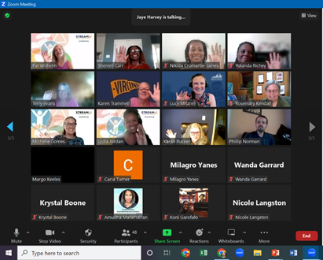
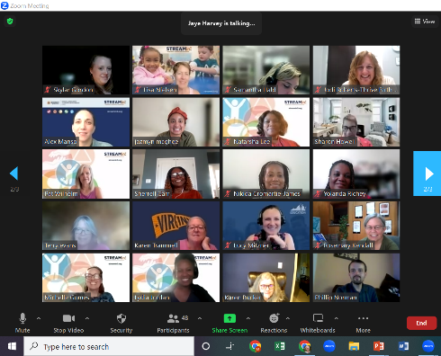
Meeting participants smiled for a few screenshots.
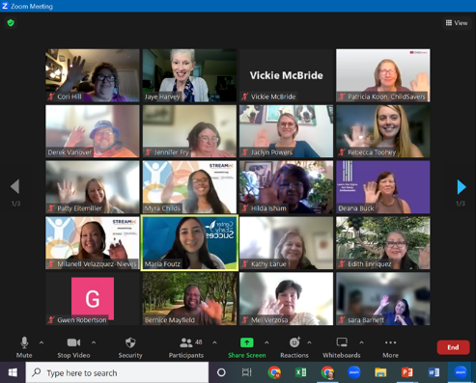

PD Essentials Meeting Summary Page 5
September 12, 2023

Announcements
- The final PD Essentials meeting for 2023 is Tuesday, December 5, 2023 from 3:00 until 4:30.
- The Southeastern Chapter of VAAEYC/Children’s Harbor 17th Annual “Raising the Bar” Conference will be on Saturday, November 4, 2023. A link for additional details is on the PD Essentials website.
- The link for the survey of meeting participants was shared and participants were encouraged to complete it.
- Continuous quality improvement suggestions were invited via chat response.
- Jaye welcomed people to reach out for any needed support for training this fall.

