PD Essentials Meeting
September 20, 2022

MEETING SUMMARY

The September 20, 2022 PD Essentials meeting included 58 early childhood PD providers (There were 92 people registered.) PD Essentials State Coordinator, Dr. Jaye Harvey, detailed the change in PD Essentials membership from a regional and agency representative membership model to welcoming all early childhood PD providers who are interested in attending PD Essentials quarterly meetings.

Participants completed a poll regarding their previous interactions with PD Essentials and/or Virginia Cross-Sector Professional Development (VCPD) and learned that most people had attended previous training, received Pointers for PD Providers, and accessed the website. Others had participated in Practice-Based Coaching training outside of PD Essentials/VCPD sponsorship.

PD Essentials Mission and History
Jaye shared the PD Essentials mission statement and a brief history of PD Essentials/VCPD. She described the evolution of PD Essentials from Virginia government initiatives in the late 2000s (e.g., Virginia Early Childhood Commission, Governor’s Working Group Professional Development Task Force) and federal project participation (e.g., Special Quest State Leadership Team, National Professional Development Center on Inclusion, Early Childhood Personnel Center.) Virginia Cross-Sector Professional Development was formed with five regions and a group of topical statewide workgroups. Initiatives have evolved over time in response to identified needs (e.g., Higher Education Faculty Institutes, Creating Connections to Shining Stars conference leadership, development and subsequent updating of competencies for trainers, VCPD 101-103 training.) In 2021, at the request of the Virginia Department of Education, VCPD became known as PD Essentials. VCPD 101-103 training has been converted to Essentials for Early Childhood PD Providers #1-5 and PowerPoint Essentials.

Upcoming Opportunities
Jaye shared the fall PD Essentials #1-5 training opportunities. Registration is open at https://web.cvent.com/event/1e714877-f542-4353-b4e8-80d14c98bbc5/summary.
Other resources include our website, www.vcpd.net, which includes upcoming events, recent updates of interest to T/TA providers, and PD resources. Presently, the recording of the VQB5 Improvement Partner Webinar on September 7, 2022 is featured.
PD Essentials Meeting Summary Page 2
September 20, 2022

Pointers for PD Providers is distributed quarterly via Constant Contact. The next issue will be distributed on October 20, 2022.

Tips and Tricks for Trainers
Jaye shared the Windowpaning training technique. Windowpaning involves drawing a series of squares in the shape of a window. Learners add a drawing to a provided term or label an existing illustration as a tool for understanding and recalling content.

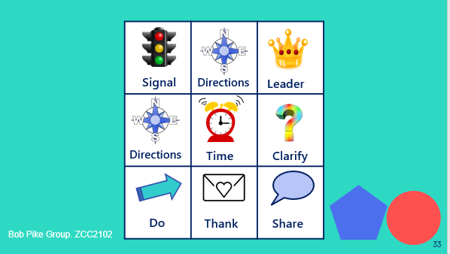

Windowpaning was illustrated using the nine-step process for managing virtual and in-person group activities. Jaye also described the use of Windowpaning and the nine-step process with the Write & Run activity included in Essentials #4, Delivering Effective and Engaging Early Childhood Training.

Networking in Breakout Rooms with Jamboard
PD Essentials meeting participants were divided into breakout rooms to discuss the following questions. Thank you to Allie Morris, Lucy Mitzner, Kim Sopko, Lisa Gehring, Susanne Rakes, Jaclyn Powers, Deana Buck, and Mary Braxton, for their breakout room leadership. See the Padlet for a record of their discussion. https://padlet.com/jhwellons/qvbrqz9fjm5hae1z
- What is a training challenge that you are experiencing currently? What strategies may address the challenge?
- What do you hope to learn or gain by participating in PD Essentials meetings?
- What can you contribute to future PD Essentials meetings or initiatives? What could you share? For example, could you share an app such as Slido or Padlet? A PD resource that you value such as a website, newsletter, book, game, activity, or prop? An idea for discussion or exploration? Your willingness to lead a breakout room discussion? Sponsorship of a training (registration, event space if in-person, etc.)? Please put your name on your post-it.

PD Essentials Meeting Summary Page 3
September 20, 2022

Announcements
- The Virginia Association for the Education of Young Children (VAAEYC) conference Call for Proposals is open. The conference is planned for March 9-11, 2023 in Richmond.
- The National Association for the Education of Young Children (NAEYC) conference is in Washington, DC on November 16-19, 2022. Jaye will present Essentials #2, Techniques for Effective and Engaging Early Childhood Training.
Upcoming Meetings
PD Essentials will meet quarterly in 2022-23. Meetings are on Tuesdays from 3:00 until 4:30. Participants should register in advance via the Zoom link on the website. PD providers also will receive a Constant Contact meeting announcement.

Register for the December 6, 2022 meeting at https://us02web.zoom.us/meeting/register/tZUpde-hqD0pHN1mwIEDS3yfkWbcXwselS29

Future meetings are planned for March 14, 2023 and June 6, 2023.

Attachments/Links to Resources
- PD Essentials Trainer Competencies
http://vcpd.net/resource-library/?fwp_search=trainer%20competencies

- Early Childhood Inclusion: What it Looks Like and Doesn’t Look Like
http://vcpd.net/resource-library/?fwp_search=looks%20like

