VCPD Meeting
September 8, 2020 * 2:30-3:45

MEETING SUMMARY

Present
Andrews, Kimberly  Armstrong, Tatanishia  Braxton, Mary  Church, Robin  DeLuca, Tracy  Devine, Hilari  Druga, Meg  Greene, Julie  Gregory, Kim  Harvey, Jaye | Henderson, Cheryl  Hill, Cori  Ingram, Kristen  Jeffries, Taundwa  Jewell, Misty  Kendall, Rosemary  Kolodzinski, Clarissa  Koon, Patricia  L’hospital, Ann  McGinnis, Mickie | Meyers, Kris  Neville, Andelicia  Paul, Stephanie  Popp, Pat  Rakes, Susanne  Sweeder, Cindy  Thomason, Kim  White, Mary Lynn  Wilberger, Sandy  Williams, Mira
Celebrations
- Today was the first day of online school for many children. It has been challenging but teachers are moving through it!
- Cheryl Henderson shared news from the JMU TTAC. Cathy Cook retired this summer and Cheryl is retiring at the end of the month. Kim Gregory joins the team at TTAC along with Meg Druga. Congratulations, Kim! Welcome, Meg!
- Congratulations to Kim Thomason for her new position as the Western District Manager for Child Care Aware.
- Since our June meeting, Kris Meyers has transitioned to the VDOE from VECF. Mickie McGinnis shared that VDSS staff now at the VDOE include Taundwa Jefferies, Saretha Williams, Rebecca McNulty-Shafer, Arlene Kasper, Lillian Taylor, and Ellie Lopez.
- Tammy Petrowicz from ICF has accepted a new position within the agency. Brandi Miller is returning as our representative from ICF.
- Mary Lynn White shared that she is now consulting for ChildSaver, and that her daughter is expecting a baby in February.
Strategic Planning
Last spring, the Governance Workgroup began working on a new VCPD Strategic Plan. They met several times virtually over the summer to incorporate information from the survey and breakout group discussions completed at our June VCPD meeting. We are grateful for the work of Laurel Aparicio, Cori Hill, Taundwa Jeffries, Kris Meyers, Mickie McGinnis, Andelicia Neville, Susanne Rakes, Sandy Wilberger, and our guest facilitator, Sharon Veatch.
Jaye highlighted the results of the surveys. See the PowerPoint slides at the end of this summary. Our new mission, vision and goals were shared.

VISION: Virginia has a high-quality, coordinated, cross-sector early childhood professional development system.
MISSION: The VCPD Team collaborates to provide diverse leadership to prepare early childhood personnel to support all children (prenatal to age five) and their families in home, school, and community settings.

GOALS:
1. Establish a stable, sustainable, and well-funded organizational structure.
2. Facilitate cross-sector coordination and collaboration in early childhood professional development at the state, regional, and local levels.
3. Prepare and strengthen the skills of early childhood professional development providers to deliver high quality education, training, and technical assistance.

VCPD members commented that they looked great and were clear and easy to follow. Members noted the importance of the first goal. Governance will continue to complete work on objectives, activities/strategies, and the evaluation plan.

VCPD Training
- VCPD 103 is a new virtual training on virtual training. Registration for three sessions is full and a waiting list has been created. An additional session or sessions will be added.
- VCPD 101 and 102 are not being offered at this time due to the nature of the content requiring face-to-face presentation. We will offer these trainings once it is safe to do so.
- Practice-Based Coaching training was converted to a virtual format and piloted this summer. Several series of this six-session training are being planned this fall and winter.
- Registration is open for the VCPD Higher Education Faculty Institute. We are collaborating with Project KSR at VCU and have internationally recognized speakers Drs. Charles Greenwood and Judith Carta along with our own Jenna Conway as keynoters. Register at https://web.cvent.com/event/360c45a1-e968-4213-8824-df798c75adb7/summary?rp=00000000-0000-0000-0000-000000000000
Designing and Implementing Learning Communities: A Peer-to-Peer PD Opportunity for Virginia's Technical Assistants
Dr. Katie Squibb from VECF shared her wisdom and work regarding learning communities for early childhood educators. Her handout is attached.

Tips and Tricks for Trainers
Jaye demonstrated a strategy for using a PowerPoint slide as a white board with participants engaging with annotation tools. See the attached PowerPoint.

Announcements
- Pat Popp shared that new McKinney-Vento early childhood resources are available on the Project HOPE website. https://education.wm.edu/centers/hope/specialtopics/ecr/index.php
- VAAEYC is moving forward with their conference planning for March. At this time, the conference may be part virtual with some onsite; however, all virtual will be implemented if necessary. https://www.vaaeyc.org/annual-conference.html
Upcoming Meetings
- VCPD Governance: September 17, 2020 at 3:00
- VCPD: November 10 and December 8, 2020 at 2:30. VCPD will not meet in October.
- Inclusive Practices Task Force: September 28, 2020 at 10:00
- Regional Consortia Workgroup: Met today. Regions are beginning to regroup after the Summer. Next meeting: December 8 at 1:15
Continuous Improvement
- What worked? Good to have new people in VCPD. We enjoy the PowerPoint themes, and pictures add quite a bit to the meeting. Great information from Katie Squibb regarding Learning Communities.
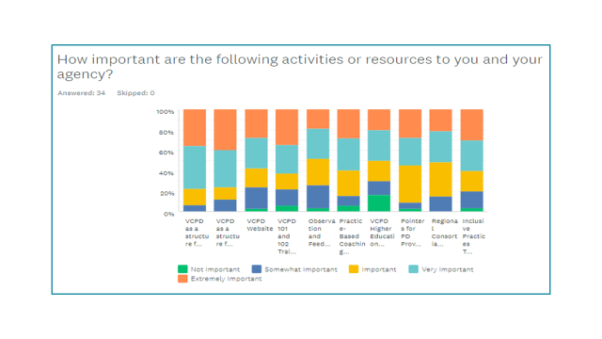
- What could be improved? Nothing noted.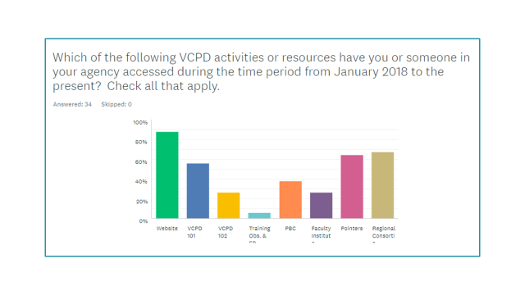

Attachments
- Ppt slides on Using a Ppt Slide as a White Board with Annotation Tools
- Organizer for Designing and Implementing Learning Communities

